# CS 340 README Template

*Use this template to complete your README file. When completing the template, keep the headings as they are so that your document has a clear organization. Remove the italicized prompt text after you have completed each section for a polished final document.*

## About the Project/Project Title

This project is designed to give a user access to the Austin Animal Center database.

## Motivation

This project was made in order to allow a client to view the animals within the database and sort through varying characteristics such as breed, age, etc.

## Getting Started

To access this project, a user needs to access the AAC database within MongoDB and obtain read/write permissions. They will also need to create a CRUD (Create, Read, Update, and Destroy) python file within Jupyter Notebook as well as a project file that sets up the dashboard and tables.

## Installation

In order to run this project, one must have MongoDB and Jupyter Notebook. Here are instructions on how to install them:

MongoDB: https://docs.mongodb.com/manual/installation/

Jupyter Notebook: https://jupyter.org/install

## Usage

### Code Example

This is how a user can access the AAC Database in MongoDB:

*one will have to create their own user in the AAC database

The following screenshots display what is needed in the CRUD file:

The following code is used to create the interactive filtering options within the project file:

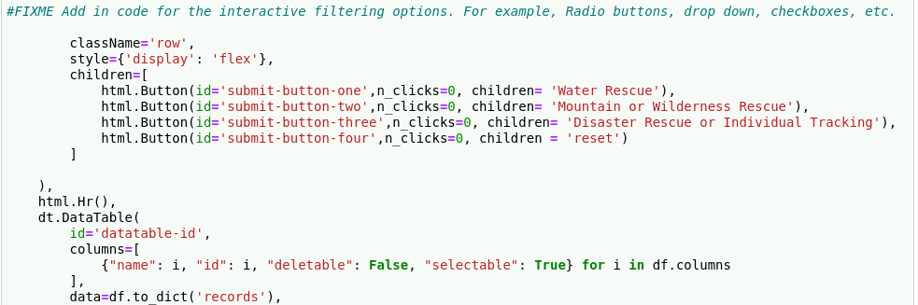

The following code is used to filter the interactive data table with MongoDB queries:  
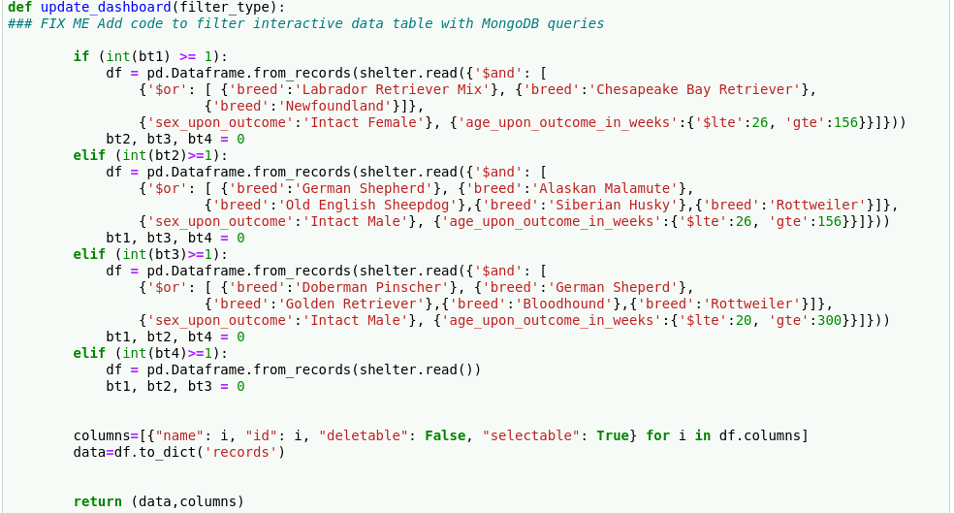

The following code is used to add in the geolocation chart:

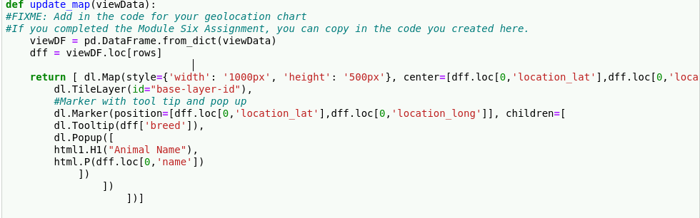

### Tests

The following code displays the tests used within this project:

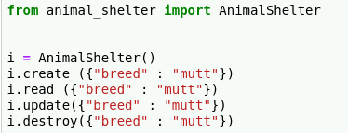

### Screenshots

I would have included screenshots of the dashboard and charts created along with what is displayed when one interacts with the dashboard, however I, unfortunately, could not gain access to the database from Jupyter Notebook.

## Contact

Zac Gonzalez